**\*Java HTML Assignment**

* **SE – Overview of IT Industry**

**1: What is software? What is software engineering?**

* Types and Examples Software is a set of instructions, data or programs used to operate computers and execute specific tasks.
* A software engineer is a person who applies the engineering design process to design, develop, test, maintain, and evaluate computer software.

**2: Explain types of software**

* The two main categories of software are application software and system software.

**3: What is SDLC? Explain each phase of SDLC**

* It is software development life cycle.
* planning, analysis, design, Implementation, testing & integration, maintenance.
* **MODULE: 2 SE – HTML and CSS**

**1: Define the terms: Website, Webpage, Web browser, Web server, HTML,CSS**

* website: A website is a collection of publicly accessible, interlinked Web pages that share a single domain name.
* Webpage: A web page is a simple document displayable by a browser.
* Web browser: A web browser is an application for accessing websites.
* Web server:  A Web server is a program that uses HTTP
* HTML: HTML (HyperText Markup Language) is a markup language that tells web browsers how to structure the web pages you visit.
* CSS: The full form of CSS is Cascading Style Sheets. It is a style sheet language used to add styles to the HTML document that will be displayed in the browsers.

**2: Create a webpage to show “This is my first HTML page”**

=<!DOCTYPE html>

<html lang="en">

<head>

    <meta charset="UTF-8">

    <meta name="viewport" content="width=device-width, initial-scale=1.0">

    <title>This is my first HTML page</title>

</head>

<body>

    <h1> This is my first HTML page</h1>

</body>

</html>



**3: Display top 10 IT companies list in html webpage**

<!DOCTYPE html>

<html lang="en">

<head>

    <meta charset="UTF-8">

    <meta name="viewport" content="width=device-width, initial-scale=1.0">

    <title> top 10 IT companies list in html webpage</title>

</head>

<body>

    <p>

        1= Hp  <br>

        2= Dell <br>

        3= Oracle <br>

        4= IBM <br>

        5= Campgemine <br>

        6= TCS <br>

        7= Wipro <br>

        8= HCL <br>

        9= Microsoft <br>

        10= Amzone <br>

    </p>

</body>

</html>

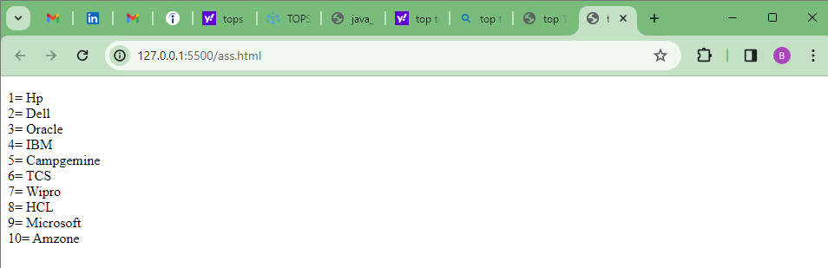

**4: Create a dropdown list**

<!DOCTYPE html>

<html lang="en">

<head>

    <meta charset="UTF-8">

    <meta name="viewport" content="width=device-width, initial-scale=1.0">

    <title> Drop-Down List</title>

</head>

<body>

    <h3> Drop-Down List </h3>

<form action="">

<select name="LANGUAGE" id="">

<option value="ENGLISH"> english</option>

<option value="HINDI"> hindi</option>

<option value="GUJRATI"> gujrati</option>

<option value="MARATHI"> marathi</option>

</select>

</form>

</body>

</html>

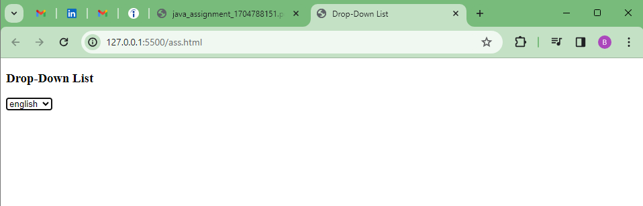

**5: Create a Table Of college Management system using row span & colspan.**

<!DOCTYPE html>

<html lang="en">

<head>

    <meta charset="UTF-8">

    <meta name="viewport" content="width=device-width, initial-scale=1.0">

    <title> collage managment data</title>

</head>

<body>

    <table border="1">

        <tr>

            <td>Roll no.</td>

            <td>Name </td>

            <td>Class</td>

            <td colspan="2">Marks(Englsih)</td>

            <td colspan="2">Marks(science)</td>

        </tr>

        <tr>

            <td>1</td>

            <td>joe</td>

            <td>3rd</td>

            <th colspan="4" bgcolor="yellow">30</th>

            </tr>

        <tr>

            <td>2</td>

            <td>Nick</td>

            <td rowspan="2" bgcolor="blue">4th</td>

            <th colspan="2">45</th>

            <th colspan="2">30</th>

            </tr>

        <tr>

            <td>3</td>

            <td>Priyanka</td>

            <th colspan="2">40</th>

            <th colspan="2">50</th>

            </tr>

    </table>

</body>

</html>

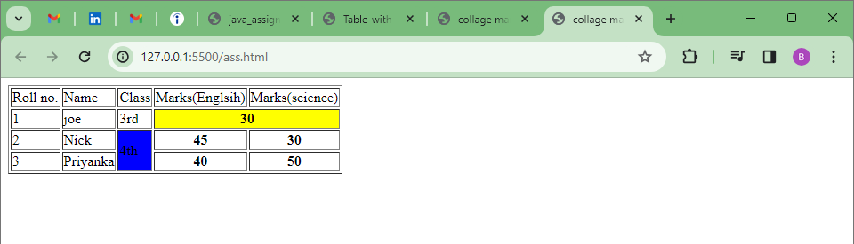

**6: Table**

<!DOCTYPE html>

<html lang="en">

<head>

    <meta charset="UTF-8">

    <meta name="viewport" content="width=device-width, initial-scale=1.0">

    <title> collage managment data</title>

</head>

<body>

    <center>

    <table border="1" bgcolor="green" style="color: white;">

<h3 style="color: black;" align="center">European roulette</h3>

        <tr>

            <td rowspan="5">0</td>

            <td bgcolor="red">3</td>

            <td bgcolor="black">6</td>

            <td bgcolor="red">9</td>

            <td colspan="2" bgcolor="red">12</td>

            <td bgcolor="black">15</td>

            <td bgcolor="red">18</td>

            <td bgcolor="red">21</td>

            <td bgcolor="black">24</td>

            <td bgcolor="red">27</td>

            <td bgcolor="red">30</td>

            <td bgcolor="black">33</td>

            <td bgcolor="red">36</td>

            <td colspan="2">2to1</td>

             </tr>

        <tr>

            <td bgcolor="black">2</td>

            <td bgcolor="red">5</td>

            <td bgcolor="black">8</td>

            <td colspan="2" bgcolor="black">11</td>

            <td bgcolor="red">14</td>

            <td bgcolor="black">17</td>

            <td bgcolor="black">20</td>

            <td bgcolor="red">23</td>

            <td bgcolor="black">26</td>

            <td bgcolor="black">29</td>

            <td bgcolor="red">32</td>

            <td bgcolor="black">35</td>

            <td colspan="2">2to1</td>

             </tr>

        <tr>

            <td bgcolor="red">1</td>

            <td bgcolor="black">4</td>

            <td bgcolor="red">7</td>

            <td colspan="2" bgcolor="black">10</td>

            <td bgcolor="black">13</td>

            <td bgcolor="red">16</td>

            <td bgcolor="red">19</td>

            <td bgcolor="black">22</td>

            <td bgcolor="red">25</td>

            <td bgcolor="black">28</td>

            <td bgcolor="black">31</td>

            <td bgcolor="red">34</td>

            <td colspan="2">2to1</td>

            </tr>

        <tr>

            <td colspan="5">1nd12</td>

            <td colspan="4">2nd12</td>

            <td colspan="4">3rd12</td>

            <td colspan="2" rowspan="2"></td>

           </tr>

        <tr>

            <td colspan="2">1to18</td>

            <td colspan="3">EVEN</td>

            <td colspan="2" bgcolor="red"></td>

            <td colspan="2" bgcolor="black"></td>

            <td colspan="2">OOD</td>

            <td colspan="2">19to36</td>

        </tr>

    </table>

</center>

</body>

</html>

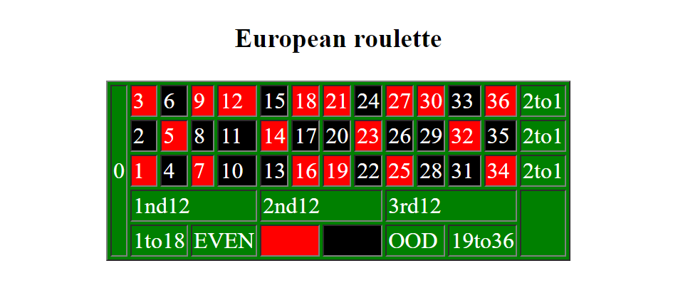

<!DOCTYPE html>

<html lang="en">

<head>

    <meta charset="UTF-8">

    <meta name="viewport" content="width=device-width, initial-scale=1.0">

    <title> collage managment data</title>

</head>

<body>

<table border="1">

<tr>

    <td colspan="2">CSS Property</td>

    <td colspan="2"> Internet Explorer</td>

    <td>fire Fox</td>

    <td>Chrome</td>

    <td>Safari</td>

    <td>opera</td>

</tr>

<tr>

    <td colspan="2">Border radius</td>

    <td colspan="2">YES</td>

    <td> YES</td>

    <td>YES</td>

    <td>YES</td>

    <td>YES</td>

</tr>

<tr>

    <td colspan="2">Box shadow</td>

    <td colspan="2">YES</td>

    <td>YES</td>

    <td>YES</td>

    <td>YES</td>

    <td>YES</td>

    </tr>

<tr>

    <td colspan="2">CSS Animation</td>

    <td colspan="2">NO</td>

    <td>NO</td>

    <td>YES</td>

    <td>YES</td>

    <td>NO</td>

</tr>

</table>

</body>

</html>

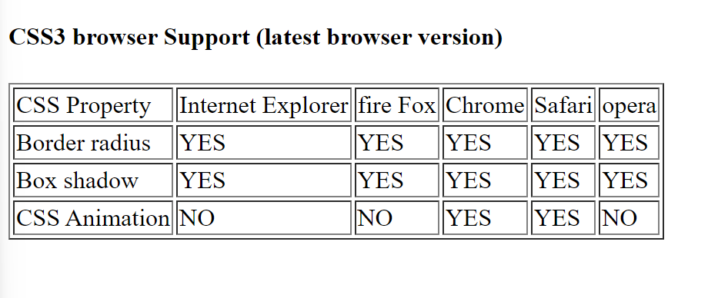

**7: Create Registration form using HTML, CSS**

<!DOCTYPE html>

<html lang="en">

<head>

    <meta charset="UTF-8">

    <meta name="viewport" content="width=device-width, initial-scale=1.0">

    <title> collage managment data</title>

</head>

<body>

<form action="">

Enter Name<input type="text" name="name" id="" placeholder="Enter Name"> <br><br>

Enter Email <input type="email" name="mail" id="" placeholder="Enter email"><br><br>

color <input type="color" name="color" id=""><br><br>

Enter Date <input type="date" name="Date" id="" placeholder="Enter date "><br><br>

Enter Month <input type="month" name="month" id="" placeholder="Enter Month"><br><br>

Enter Number <input type="number" name="number" id=""><br><br>

Enter your password <input type="password" name="" id="" placeholder="Enter Your Password"><br><br>

search <input type="search" name="serch" id=""><br><br>

<button style="height: 20px;width: 60px;">Submit</button>

</form>

</body>

</html>

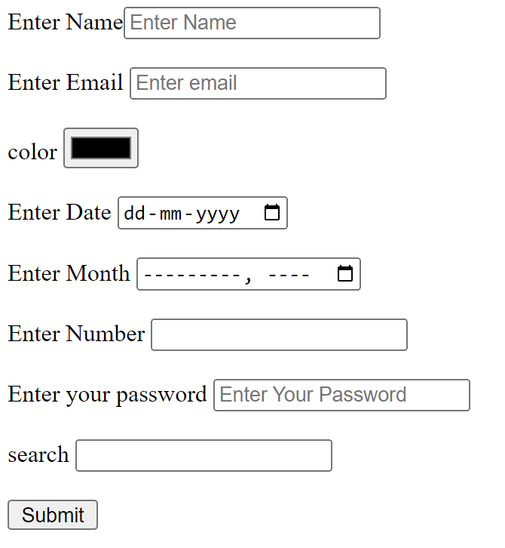

**8: In how many ways can a CSS be integrated as a web page?**

=There are 3 way to use CSS

1 external CSS

2 inline CSS

3 internal CSS

**9: Create simple three pages using External CSS, Internal CSS, and Inline CSS.**

1 external CSS

<!DOCTYPE html>

<html lang="en">

<head>

    <meta charset="UTF-8">

    <meta name="viewport" content="width=device-width, initial-scale=1.0">

    <title> collage managment data</title>

</head>

<style>

    .div{

        background-color: red;

        color: white;

    }

</style>

<body>

    <p class="div">Lorem ipsum dolor, sit amet consectetur adipisicing elit. Fuga ea incidunt tempora eum repellat perferendis aliquam optio tempore dignissimos, id, suscipit quidem quas repellendus quae autem minus omnis veniam. Ab.</p>

</body>

</html>

2 internal CSS

<!DOCTYPE html>

<html lang="en">

<head>

    <meta charset="UTF-8">

    <meta name="viewport" content="width=device-width, initial-scale=1.0">

    <title> collage managment data</title>

</head>

<style>

    #div{

        background-color: red;

        color: white;

    }

</style>

<body>

    <p id="div">Lorem ipsum dolor, sit amet consectetur adipisicing elit. Fuga ea incidunt tempora eum repellat perferendis aliquam optio tempore dignissimos, id, suscipit quidem quas repellendus quae autem minus omnis veniam. Ab.</p>

</body>

</html>

3 inline CSS

<!DOCTYPE html>

<html lang="en">

<head>

    <meta charset="UTF-8">

    <meta name="viewport" content="width=device-width, initial-scale=1.0">

    <title> collage managment data</title>

</head>

<body>

    <p style="height: 50px;width: 60px;background-color: aqua;">Lorem ipsum dolor, sit amet consectetur adipisicing elit. Fuga ea incidunt tempora eum repellat perferendis aliquam optio tempore dignissimos, id, suscipit quidem quas repellendus quae autem minus omnis veniam. Ab.</p>

</body>

</html>